STAINLESS STEEL HINGE

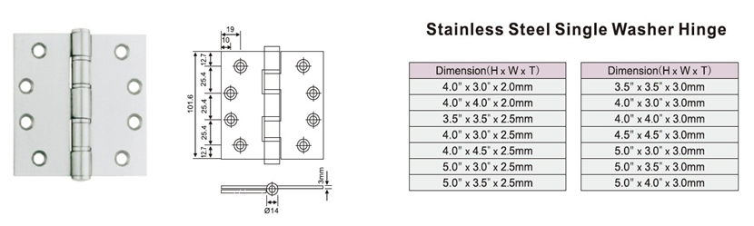**HINGE**

|  |  |  |
| --- | --- | --- |
| **FEATURES** | | |
| **Model** | **UK-S 003** | |
| **Usage** | Wooden Door, Metal Door, Steel Door, Interior Door, Outer Door | |
| **Material** | Stainless Steel 304 / 316 / 201 | |
| **Finish** | SSS, PSS, PVD, PB, AB, AC | |
| **Intended uses:** | On non-fire compartmentation doors fitted with door closing devices (to enable such doors to close reliably and thus achieve self-closing) | |
| **Dangerous substances** | Note 1 of ZA 1 | No dangerous substances declared for this Product/intended use. |